NHL Shot Outcome Prediction Model  
  
Team Members:  
Aidan Lee, Max Weinstein  
  
10/21/24

## **1. Project Goal**

Hockey, especially played in the National Hockey League, is known for being a very fast-paced sport, where every shot on goal is crucial. In each game of hockey, each team takes an average of 30 shots on goal, with the more shots taken, the higher likelihood of a goal being scored. This project aims to analyze a dataset of hockey shots taken in the National Hockey League (NHL), during the 2021-2022 season. We want to focus on the outcome of these shots: resulting in a goal, being blocked, or not being on target at all.   
  
We will utilize a dataset of 160,573 attributes and 21 attributes, data on every shot from every NHL game during that season. Our attributes are based on the following categories:

1. Shot Data:   
    The distance from the goal, and the angle to the goal
2. Game Context:   
    Current score, current period, power play

Based on these attributes, plus a few additional ones provided by the dataset, we want to develop a multi-classification model that will accurately predict the shot outcomes. The model we will create would have several practical applications:

1. Training Tools:   
    Coaches can create simulations to demonstrate shot opportunities based on several factors, in order to teach the players what to look for
2. In-Game Analysis:  
    Based on information from the model, the coaches of a team can adjust the strategy to be more or less aggressive on offense, based on factors such as them taking shots at bad moments, or not taking viable shots.
3. Post-Game Analysis:   
    A combination of the two prior applications, coaches can use this model when reviewing the game film with the players post-game. By showing the shots, and the models opinion on them, while looking at the game from a birds-eye view, players can learn from their mistakes.

Throughout the project, we hope to find the most influential attributes towards the shot outcomes, and identify the most effective model for predicting shot results.

**2. Dataset Description**We sourced the dataset from this project from the SCORE Network Sports Data Repository, and like we mentioned earlier, it accounts for every shot taken during the 2021-2022 NHL season.   
  
The data includes detailed shot information, such as the score of the game, the home and away teams, which period the shot was taken in, and whether the shot was on an empty net. Like most sports, the context of the game is crucial for the analysis of it, and with the factors of several players moving around the rink rapidly in hockey, the more contextual information we can get, the better.  
  
The dataset provided a nominal class variable of shot_outcome, which made the classification approach easier. The variable had 4 outcomes:

* **SHOT:** A shot on goal, blocked by the goalie
* **MISSED_SHOT:** A shot that missed the goal, without being blocked
* **BLOCKED_SHOT:** A shot on goal, blocked by a non-goalie player
* **GOAL:** A shot on goal, that resulted in a goal

## **3. Pre-Processing**

3.1 - Removing Unnecessary Attributes

We started by removing some of the attributes that had no significance to us, and would just mess with the model’s accuracy when making a prediction, with a large amount of these being names. Here are the attributes we removed:

* game_id: The ID for the game, likely to be used in the NHL API  
   *Ex: 2021020001*
* description: A description of the shot, with player names and shot outcome.  
   *Ex: “Steven Stamkos Wrist Shot saved by Tristan Jarry”*
* home_name & away_name: The names of the home and away teams in the game  
   *Ex: “Tampa Bay Lightning”*
* event_team: Which team the shooter was on  
   *Ex: “Tampa Bay Lightning”*
* event_player_1_name: The name of the shooter  
   *Ex: “Steven.Stamkos”*
* event_player_1_type:   
   The type of player. Depends on shot outcome, which we can use instead.  
   *Ex: “Shooter” or “Scorer”*
* event_goalie_name & event_player_2_name: The name of the goalie being shot on  
   *Ex: “Tristan.Jarry”*
* event_player_2_type:   
   The type of the second player involved, depends on shot outcome  
   *Ex: “Goalie”, “Blocker”*

3.2 - Removing Null Data

Before transforming the data, we wanted to remove null data, because it would affect the accuracy of the model, because of its reliance on having the context around the shot.

Starting with the variables that seemed to have the largest effect on the context of the shot, shot_distance & shot_angle had 38,224 instances where they were missing, so we dropped all of them, leaving the dataset with 120,556 instances. This correlated with the BLOCKED_SHOT category in the class variable, which completely disappeared after dropping these rows, leaving us with 3 outcomes: SHOT, GOAL, MISSED_SHOT.  
  
Next, strength_code had 303 instances where it was missing, and with such a low number of instances for what seemed like a major variable, we also dropped those instances from the dataset, leaving us with 120,253 instances.  
  
Then we came to a trickier part, where the only other variable with missing values was empty_net, having 111,742 instances where it was missing, which represented 93% of the total dataset. With it being a decently important attribute, we decided to try and keep it by filling in the missing values. We settled on Random Sampling Based on Proportions, where we kept the distribution of the filled in values, and randomly assigned missing values to True/False, while keeping the existing proportion, going from [517, 7,994] true/false to [7,272, 112,981] true/false, but we also saved a dataset with the missing values dropped if we needed to use it for some reason later. A random seed of ‘20241009’ was used when randomly assigning the values, for reproducibility.

3.3 - Transforming Data

We then transformed some variables, so that the model would have an easier time interpreting them. Transformations were performed using Python, by loading our dataset with Pandas, then manipulating the DataFrame object.

* empty_net: “TRUE” / “FALSE” -> True/False  
   Converted to boolean
* game_seconds_remaining (Numeric):  
   We did several things with this variable. Starting off, there were negative values, which shouldn’t exist for a variable calculating how much time is left in the game, and with less time left, teams become more aggressive about scoring, so incorrect values could mess with the model. There are some instances with 0 as the value, but we will ignore those for now, assuming that they were probably close enough to the end of the game that it wouldn’t matter much. As a result, we chose to drop the rows where the variable was negative, removing 2,163 instances.  
    
   Secondly, the range of the variable is pretty large, being 3597 seconds. We decided to normalize the data using min-max normalization, which scaled it to values between 0 and 1.
* period_seconds_remaining (Numeric):   
   Similar to game_seconds_remaining, but didn’t have any negative values. Normalized with min-max normalization.
* x_fixed & y_fixed (Numeric):   
   With ranges of [-99, 99] and [-42, 42], we normalized this with Z-score normalization, so that it would keep the aspect of it being centered around 0, after normalization.
* shot_distance (Numeric):  
   With a large range, but mostly skewed to being closer to the goal, we normalized it with Z-score normalization.

3.4 - Splitting to Training/Validation/Testing

Then using Pandas in Python, we did a 70/15/15 split on the cleaned dataset. 70% of the total dataset will go into a training dataset, 15% will be a validation dataset, and the final 15% will be the testing dataset. The same random seed of “20241002” was used for the splitting. This resulted in: 84,177 instances in the training dataset, 18,038 instances in the validation dataset, and 18,038 in the training dataset. Stratify was used to preserve the distribution of the class variable in each dataset, so they would all end up with basically the same distribution: ~65.9681% SHOT, ~26.8541% MISSED_SHOT, ~7.1793% GOAL.

## **4. Attribute Selection and Model Classifiers**

After the pre-processing stage of our project, our dataset was left with 11 attributes:

1. period
2. period_seconds_remaining
3. game_seconds_remaining
4. home_score
5. away_score
6. empty_net
7. strength_code
8. x_fixed
9. y_fixed
10. shot_distance
11. shot_angle

Class Attribute: shot_outcome

4.1 - Attribute Selection Algorithms

1. **CfsSubsetEval:**We used WEKA for this selection algorithm. We used BestFirst as the search method. After running it, it selected the following 6 variables as being the most related with the class variable:

* home_score
* away_score
* strength_code
* x_fixed
* y_fixed
* shot_distance

1. **InfoGainAttributeEval:**Using WEKA, we ran InfoGainAttributeEval with the Ranker search method. Here is what was outputted:

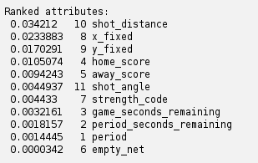  
Based on this, setting a threshold at 0.005, we will only keep 4 attributes, ranked highest to lowest correlation with the class variable:

* shot_distance
* x_fixed
* y_fixed
* home_score
* away_score

1. **CorrelationAttributeEval:**

Using WEKA, we ran CorrelationAttributeEval with the Ranker search method. Here was the output:

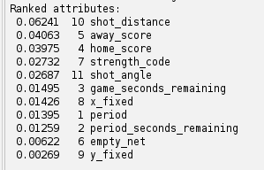  
Based on this, with a selected threshold of 0.015, we will keep the following attributes:

* shot_distance
* away_score
* home_score
* strength_code
* shot_angle

1. **GainRatioAttributeEval**

Using WEKA, we ran GainRatioAttributeEval with the Ranker search method. Here is the output of that:  
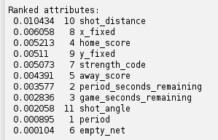  
  
With a selected threshold of 0.005, we will keep the following attributes:

* shot_distance
* x_fixed
* home_score
* y_fixed
* strength_code

1. **Mutual Information:**We chose to use the mutual information algorithm, because it works well with both categorical and continuous data, which is good for our dataset, containing continuous data like shot_distance, and categorical data like strength_code. In addition to that, it is also able to capture linear and non-linear relationships, meaning that it can interpret more complex relationships to the class variable if needed. We ran using Python3 with the scikit-learn library, which contains a mutual_info_classif function in its feature_selection library.

Here is the essential part of our script, where df is our loaded dataset:



X = df.drop('shot_outcome', axis=1)

y = df['shot_outcome']

X = pd.get_dummies(X, drop_first=True)

scaler = StandardScaler()

X_scaled = scaler.fit_transform(X)

mi_scores = mutual_info_classif(X_scaled, y, discrete_features='auto')

mi_scores = pd.Series(mi_scores, index=X.columns)

mi_scores = mi_scores.sort_values(ascending=False)



Here is what the script outputted:  
 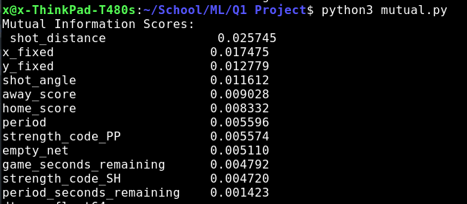

Setting a threshold value of 0.01, based on this algorithm, we should keep the following attributes:

* shot_distance
* x_fixed
* y_fixed
* shot_angle

4.2 - Classifier Models